* Screenshot of Model Plot

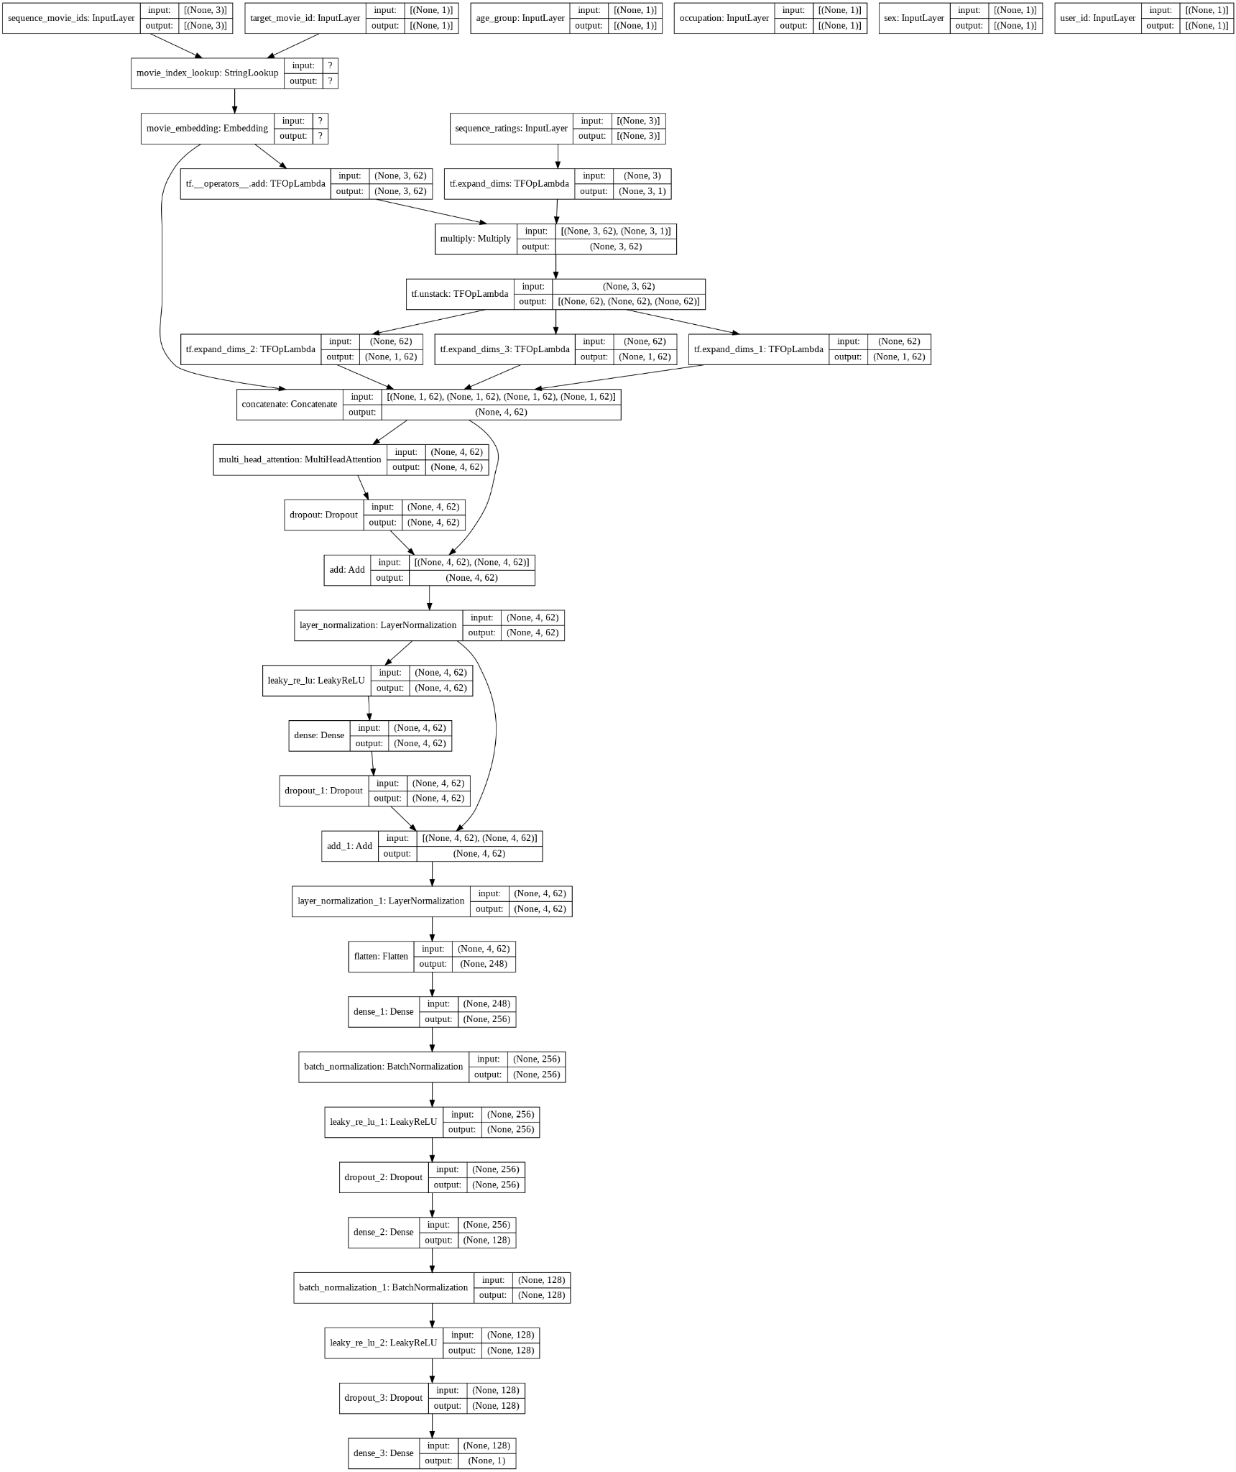

* Screenshot of Test RMSE:

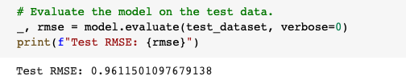

* Screenshot of Model Train and Val Plt plot:

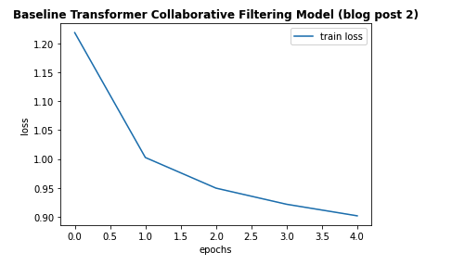

* Parameters:
  + 1 transformer block
  + 3 heads (multi-attention)
  + Lr = 0.01, Adagrad optimizer
  + include_user_id = False
  + include_user_features = False
  + include_movie_features = False
* Tensorboard:
  + Link to Tensorboard:
  + Screenshot of Tensorboard
* Ratings Predictions and Movies Recommendation Using Trained Baseline Model
  + Movie Ratings Prediction of User with ID = 2000
  + Recommended Movies for User with ID = 2000 based on Predicted Ratings